Allen Quinones
Prof. McHann
CS-255
October 14, 2026

CS 255 System Design Document

UML Diagrams

UML Use Case Diagram
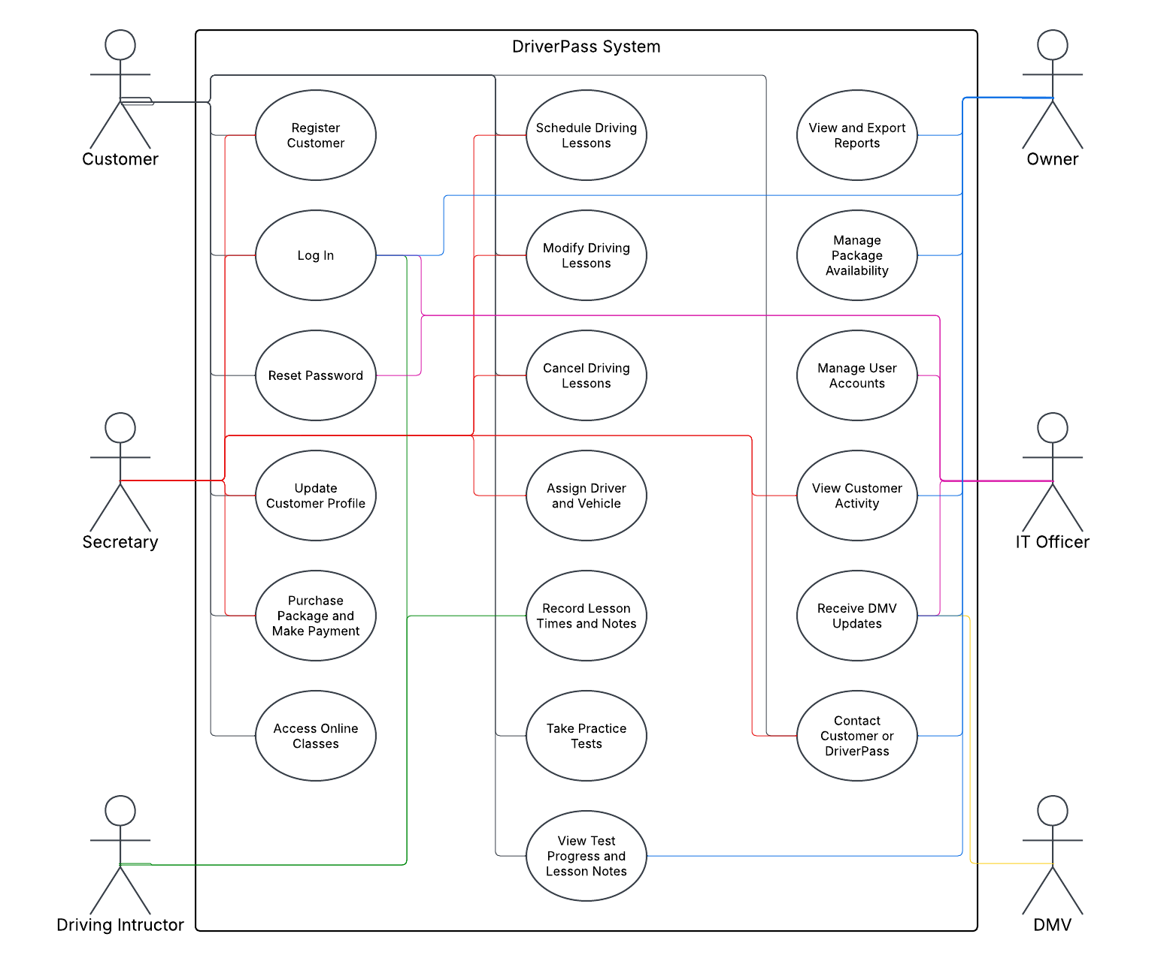

UML Activity Diagrams
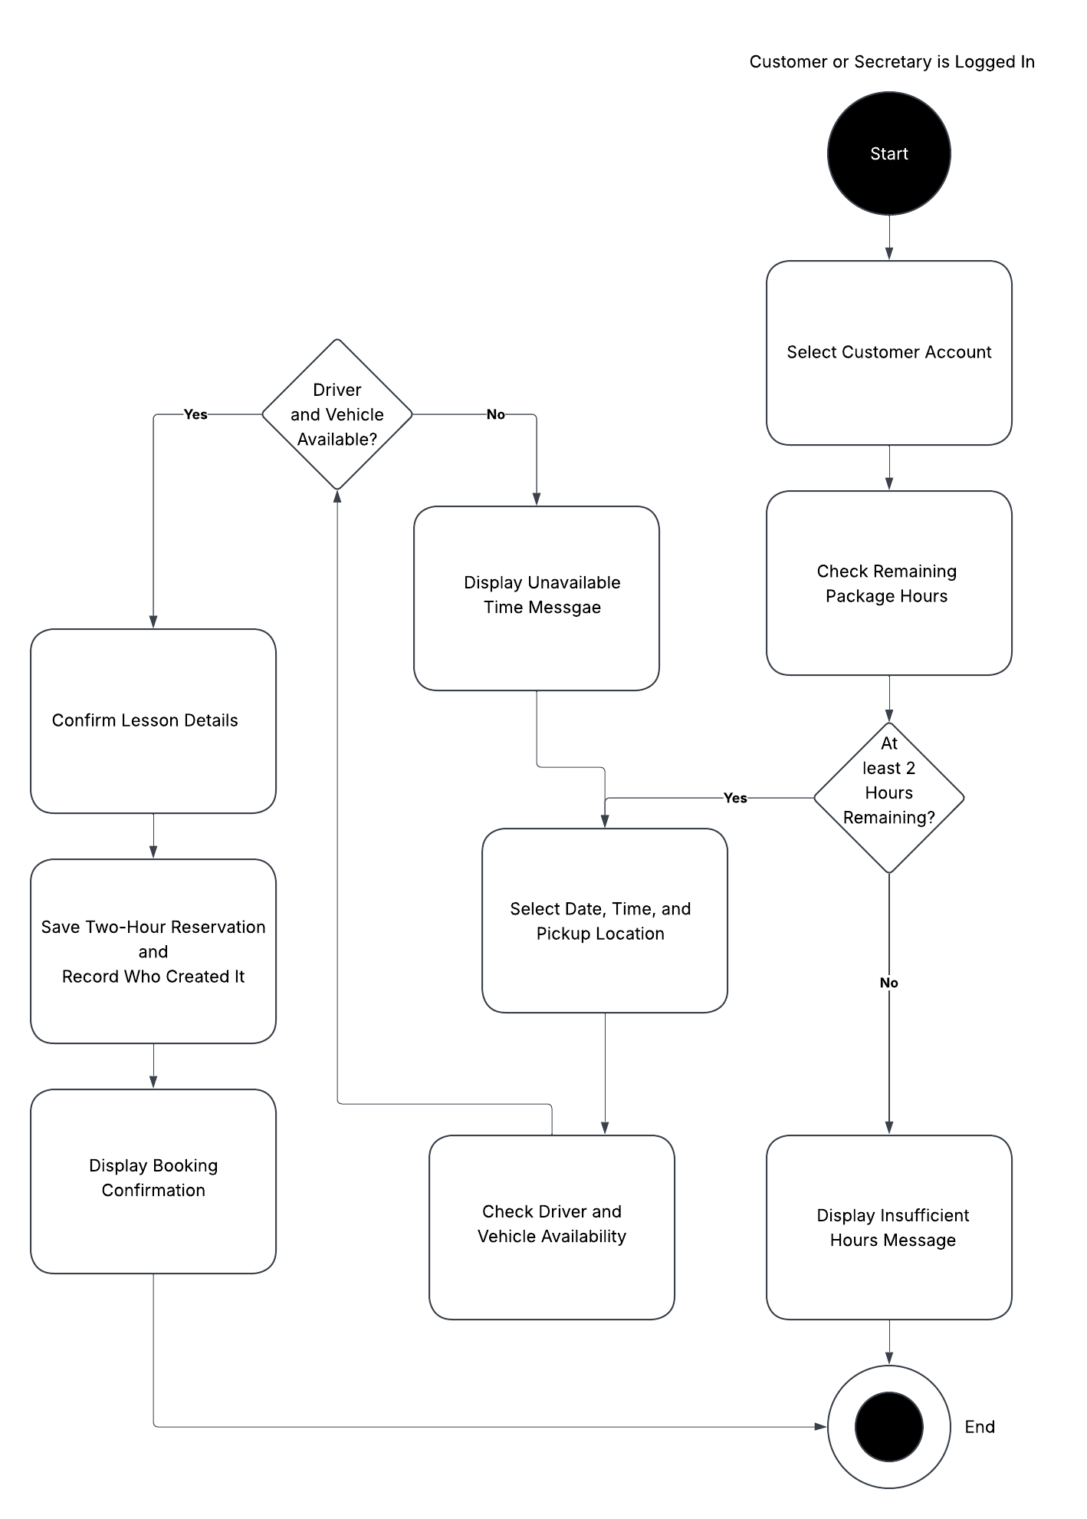
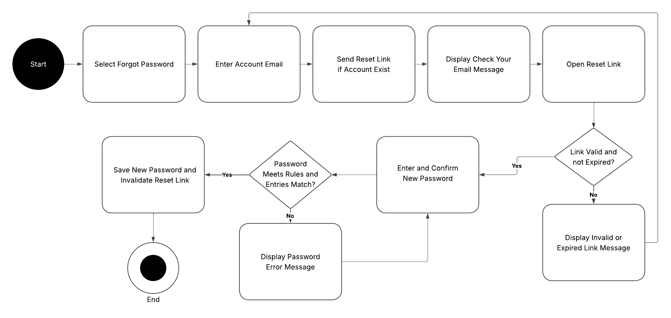

UML Sequence Diagram
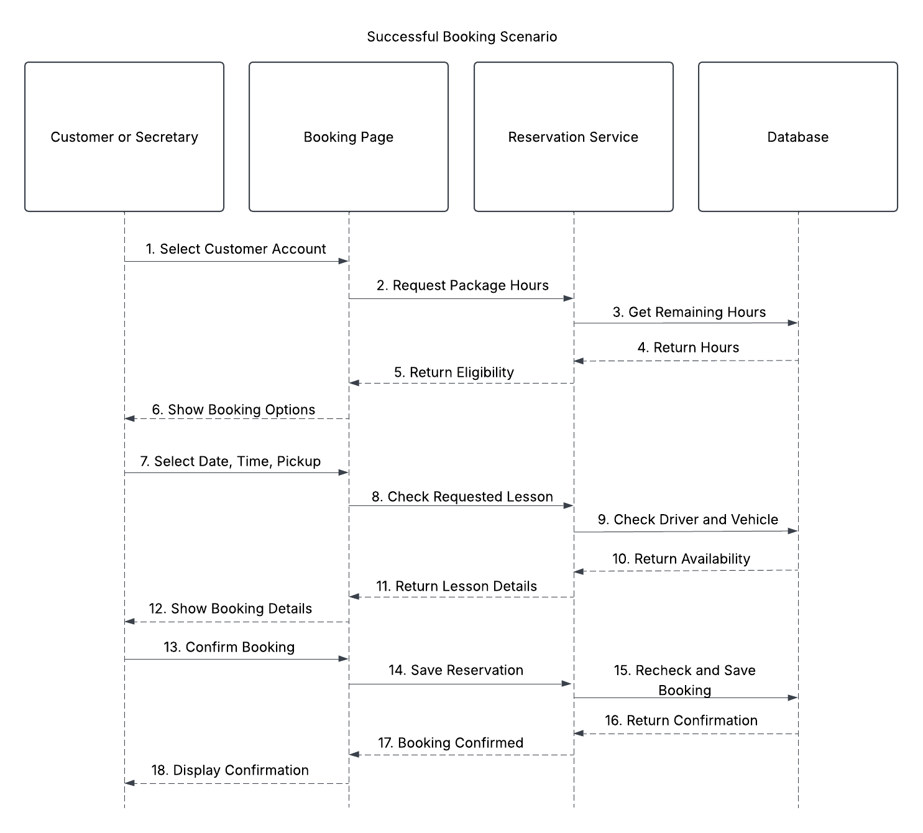

UML Class Diagram
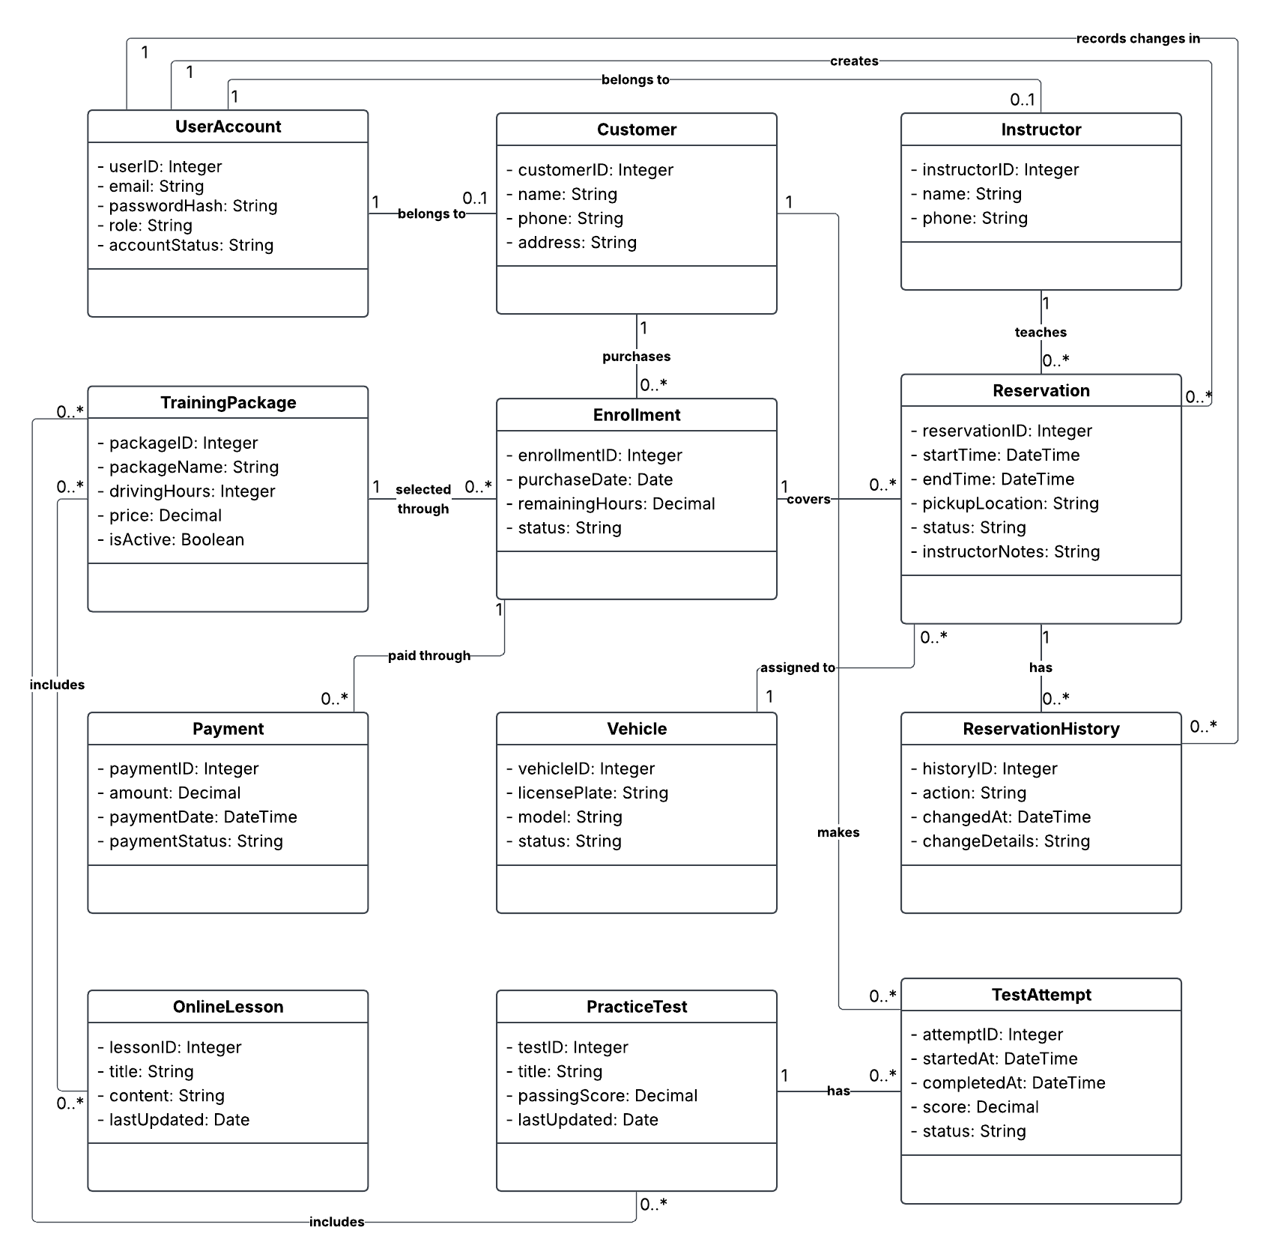

Technical Requirements

DriverPass needs a cloud-hosted website that customers and employees can access on any device, including a computer, tablet, or smartphone. Users will need a reliable internet connection and an updated web browser. Office staff will need computers and network access to manage customer accounts, reservations, and reports. The cloud service will provide the servers and storage needed to run the system. A relational database will store customer records, training packages, lesson reservations, and test results. Before saving a reservation, the system will check package hours and instructor and vehicle availability to prevent scheduling conflicts. Employees can also download reports for offline viewing, but they need an internet connection to update records.

The system will use secure HTTPS connections, password hashing, and role-based access permissions. This helps protect customer information while still letting employees access what they need to do their jobs. An email service will send password reset links, and a payment service will process online purchases. The system will track reservation changes, including who made each change and when. Automated backups and monitoring tools will help recover lost information and identify problems. It will also need a way to receive DMV updates so training materials stay current. Developers will use a code editor, version control, and a separate testing environment to review changes before release.

